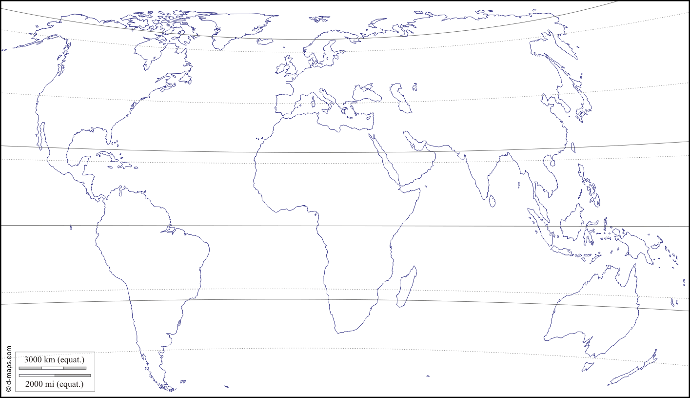

Polar Climates

Temperate Climates

Tropical Climates

