Unit I: The World in Spatial Terms
Human-Environment Interaction

Circle the terms you are not familiar with:

- Human-Environment Interaction
- Desertification
- Sahel
- Desalinization
- Aral Sea
- Chernobyl
- Natural Resource
- Renewable resource
- Nonrenewable resource
- Inexhaustible energy source

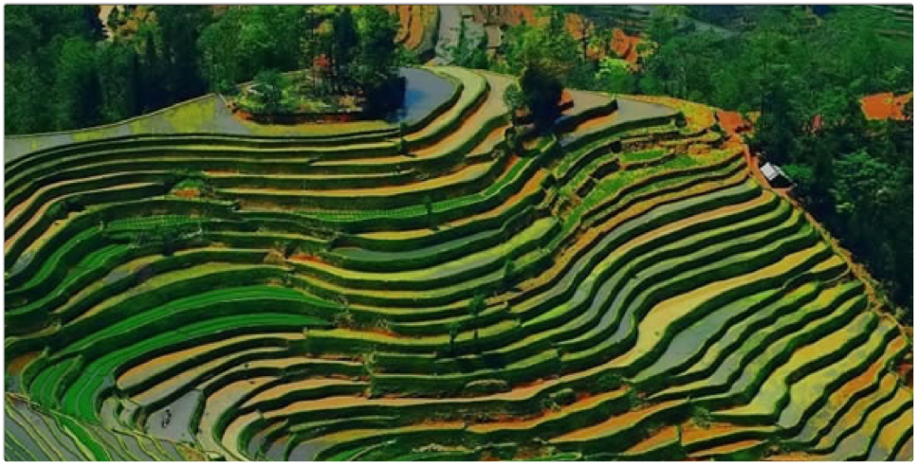
Human-Environment Interaction

Adaptation  Examples: | Modification  Examples: | Dependency  Examples:

Important HEI Examples | Desertification | Sahel
Desalinization | Aral Sea | Chernobyl

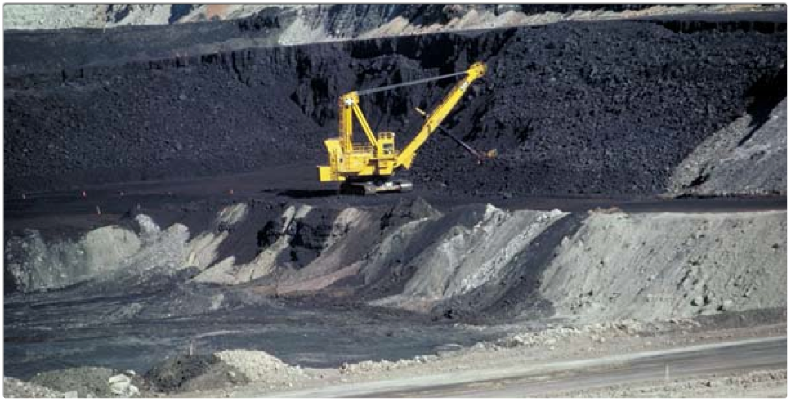
Natural Resources

Examples:

Renewable vs Nonrenewable
- Natural resources are abundant but are not distributed equally around the world.
- Geographers divide natural resources into three basic types:
  - Renewable resources:
    - Examples:
  - Non-renewable resources:
    - Examples:
  - Inexhaustible energy sources:
    - Examples:

