Unit I: The World in Spatial Terms
Weather & Climate

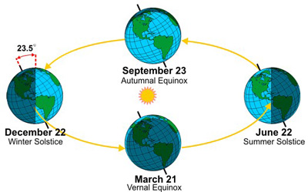
The reason for seasons:

What is the importance of the Tropic of Capricorn and the Tropic of Cancer (i.e. The Tropics)?

Weather: | Climate:

What causes weather?
Water Vapor: this determines whether there will be precipitation.
- Precipitation: falling water droplets in the form of rain, sleet, snow, or hail.
Cloud Cover: clouds may hold water vapor.
Landforms and Bodies of Water: water heats slowly but also loses heat slowly. Land heats rapidly but also loses heat quickly.
Elevation: as elevation above sea level increases, the air becomes thinner and looses its ability to hold moisture.
Air Movement: winds move the air and the solar energy and moisture it holds. As a result, weather can change rapidly.

Types of Precipitation
Convectional:  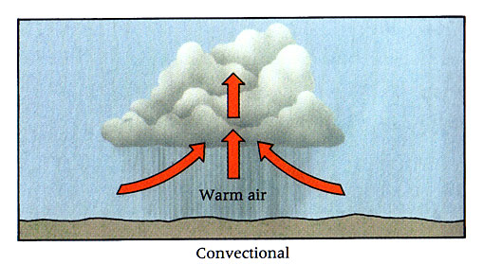 | Orographic:  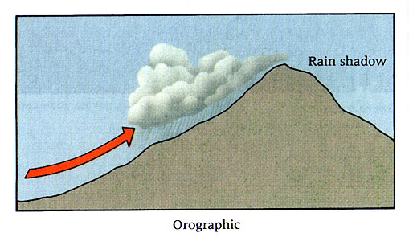 | Frontal:  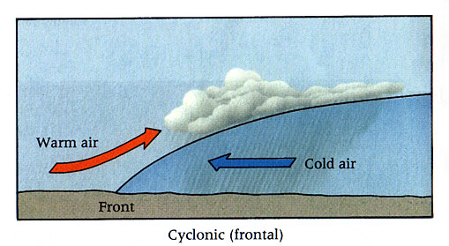

Weather Extremes | Hurricane:
Tornado: | Blizzard:
Drought: | Flood:
Factors Affecting Climate
Latitude:

Air Masses:

Continentality:

Elevation:

Mountain Barriers:

Ocean Currents:
Pressure Cells:

Storm Tracks:

