Unit I: The World in Spatial Terms
The Changing Planet

Circle the terms you are not familiar with:

- Plate Tectonics
- Subduction
- Earthquake
- Magma
- Lava
- Volcanism
- Erosion
- Weathering
- Mechanical Weathering
- Chemical Weathering
- Acid Rain

Our Ever Changing World
The Earth's surface changes constantly.
- Coastlines shift.
- Islands rise from the sea.
- Mountains grow to towering heights or shrink to rolling hills.
Many of the changes aren't noticeable in a lifetime, but in geological time - which is measured in millions of years - the transformations are dramatic.
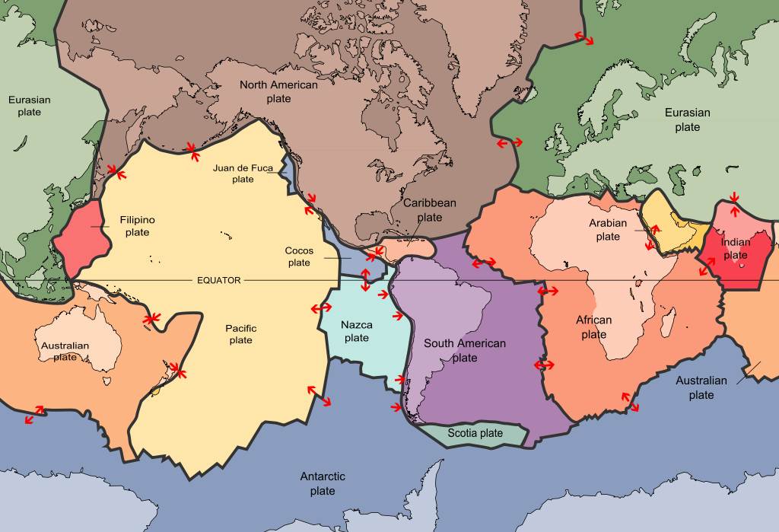
Plate Tectonics
Plates:

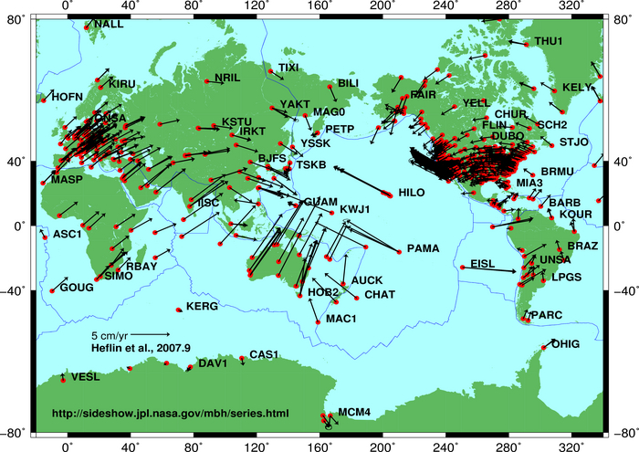
What causes plates to move?

Plate Tectonics:

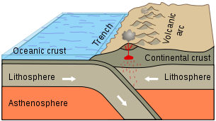
Subduction

What are some examples of subduction?

Natural Disasters
Earthquakes | Volcanoes

Weathering & Erosion
Weathering  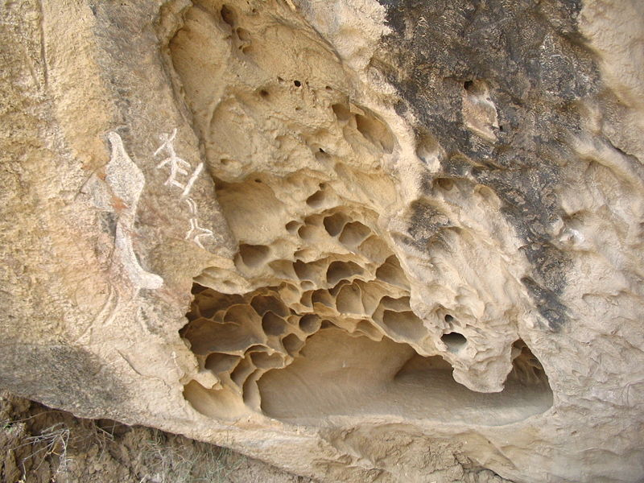 | 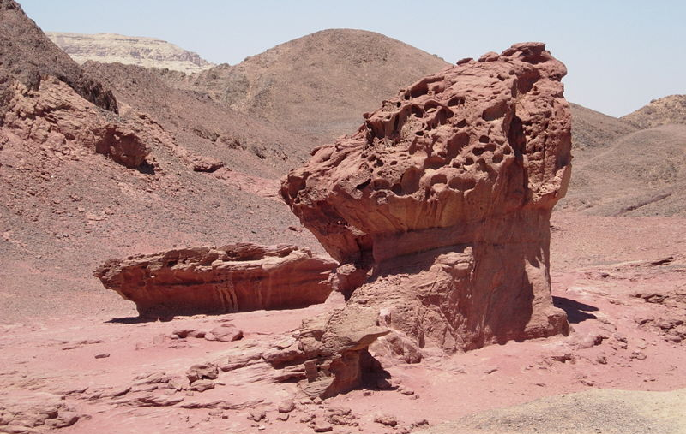  Erosion

Types of Weathering
Mechanical Weathering | Chemical Weathering

Types of Erosion
Water Erosion | Wind Erosion | Glaciation

