5 Themes of Geography
Movement:

Region:

Formal Region: | Functional Region: |  | Perceptional Region:
Location

Relative Location: |  | Absolute Location:
Human-Environment Interaction:

Place:

Longitude/Latitude
Map Projections – Mercator/Robinson
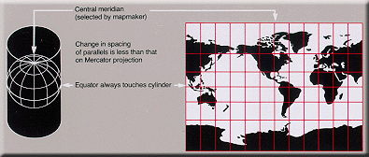
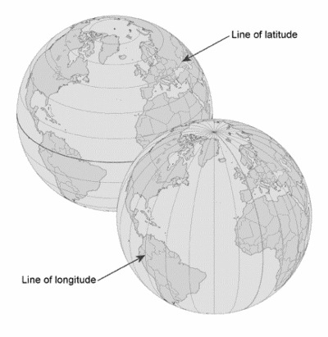
Equator

Prime Meridian

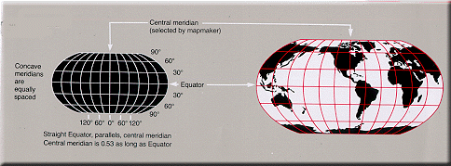

Parts of a Map

Latitude/Longitude BINGO

B | I | N | G | O
Free
Space

